1.Inverting Amplifier.
I/P: SINE Wave
Dc offset[V]: 0v
Amplitude[V]: 1v
Freq[Hz]: 50Hz
Dual Supply Voltage: 6v
O/P:
The output wave is sine wave(with ), due to dual supply voltage the wave
oscillates between 6v - -6v.
1.Circuit Diagram. 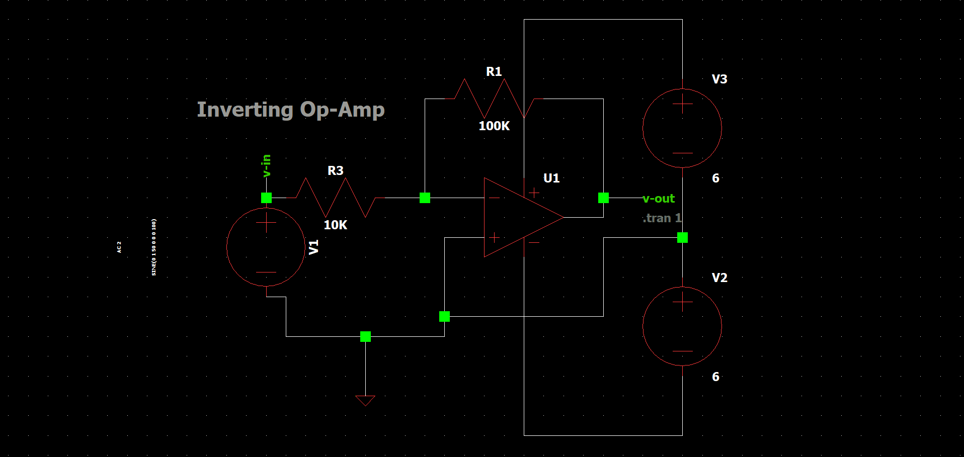
2.Waveform.
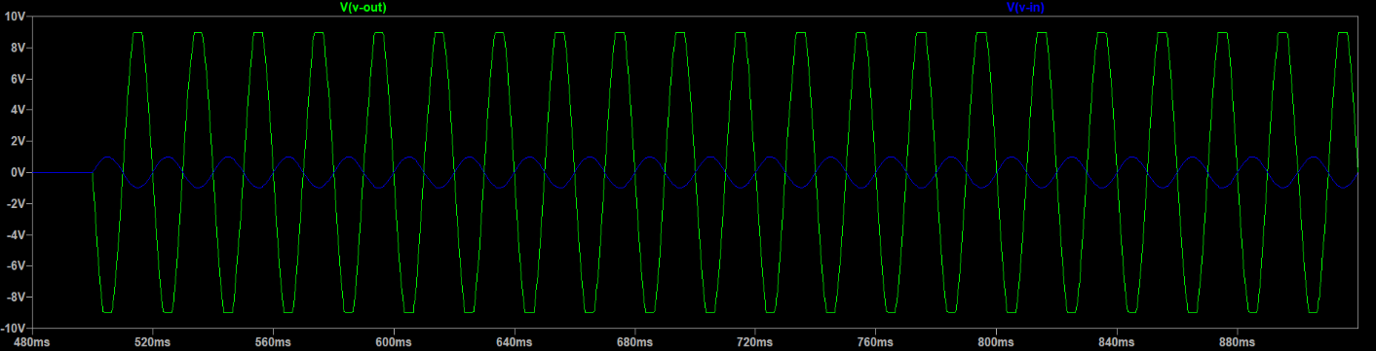
3.Components used.
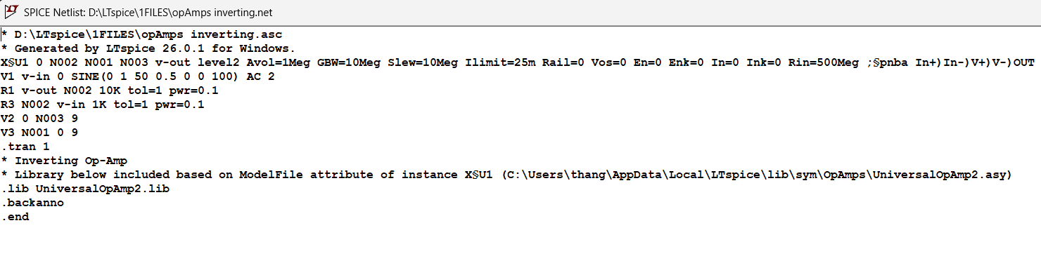
2.Non-Inverting Amplifier.
I/P: SINE Wave
Dc offset[V]: 0v
Amplitude[V]: 1.2v
Freq[Hz]: 60Hz
Dual Supply Voltage: 6v
O/P:
The perfect sine wave appear in output, it oscillate between supply voltage 6v
1.Circuit Diagram.
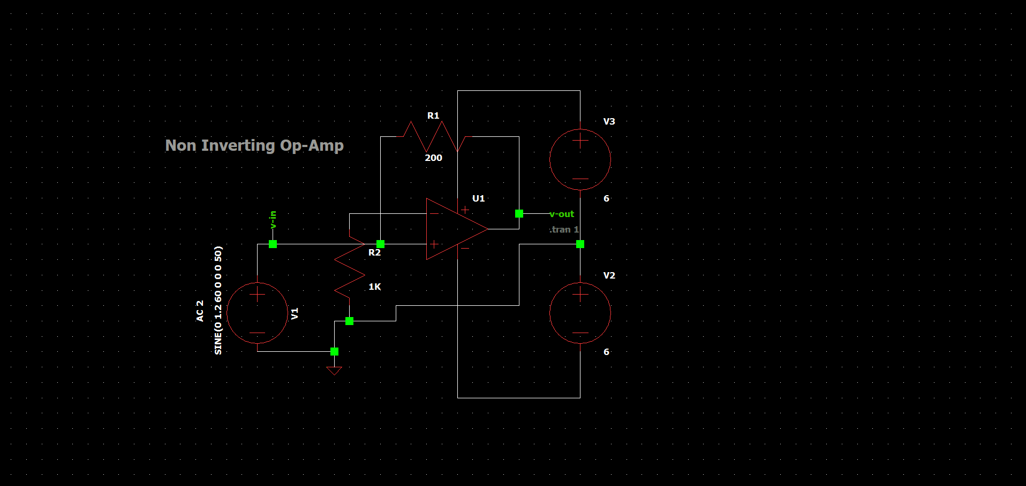
2.Waveform.
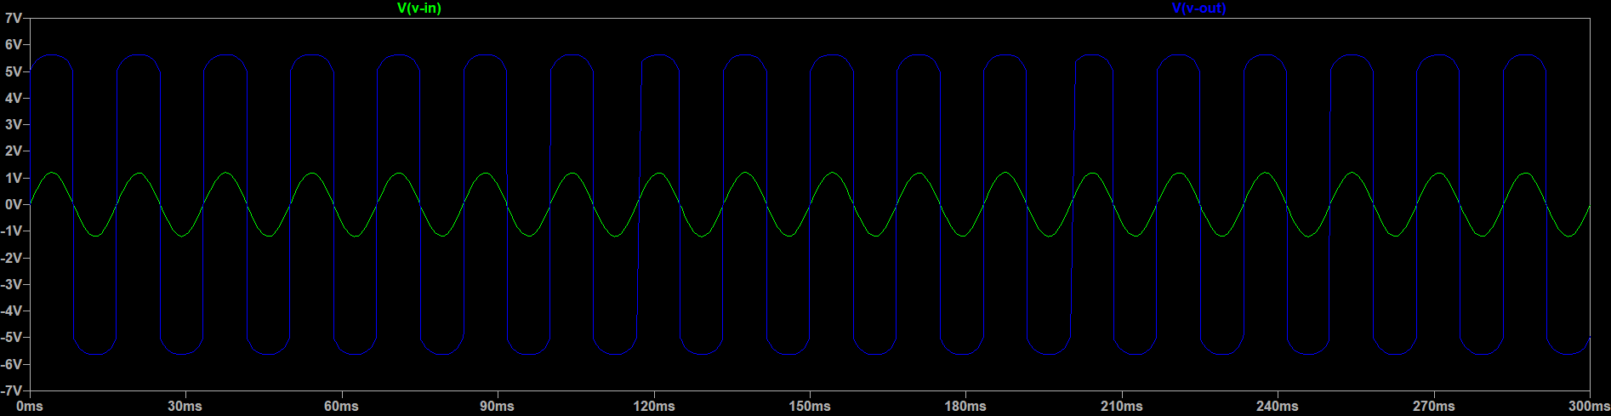
3.Components used.
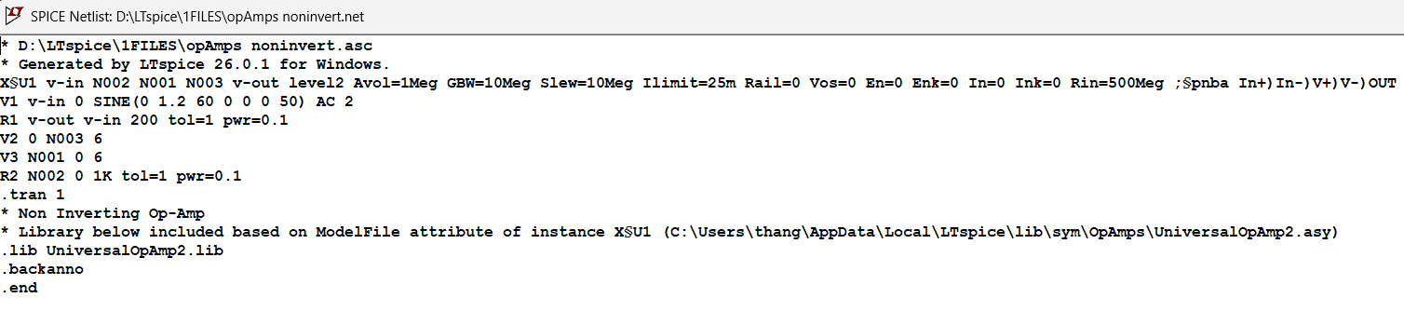
3.Summing Amplifier.
I/P: DC Voltage
V1 = 3v
V2 = 5v
V3 = 2v
O/P:
The output is sum of input voltages, the output obtained and verified.
1.Circuit Diagram.
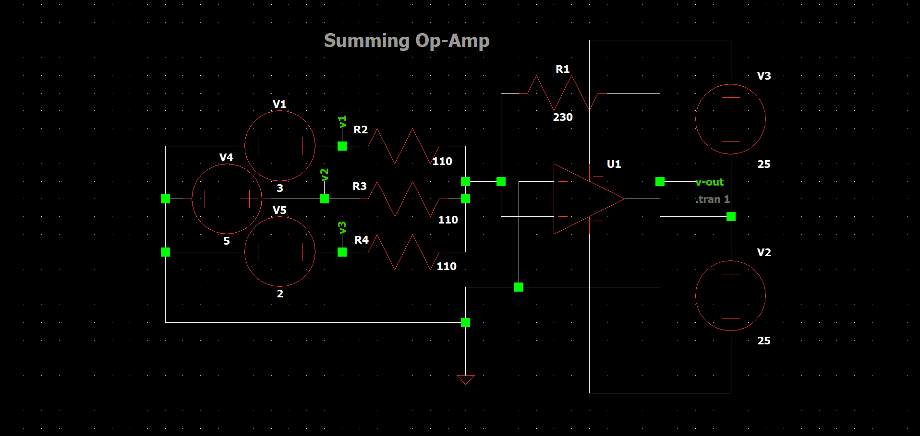
2.Waveform.
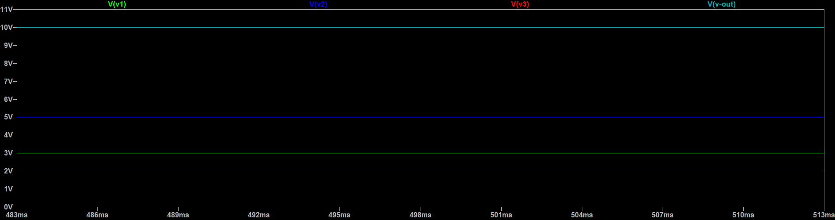
3.Components used.
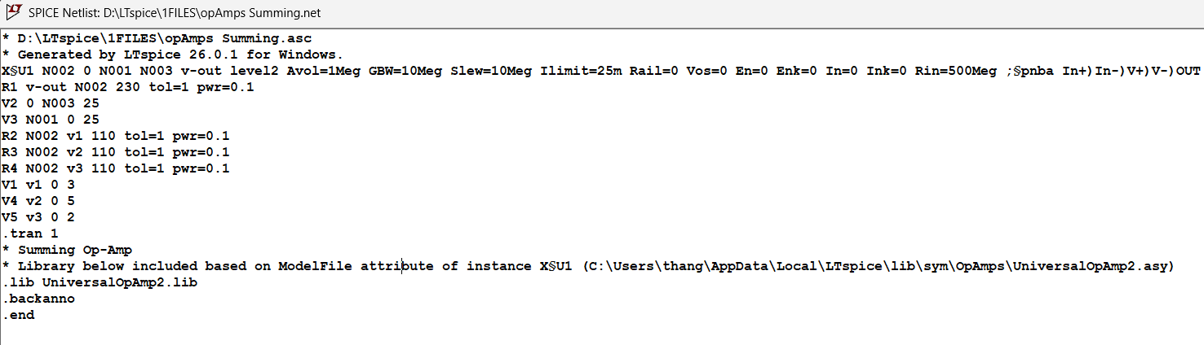
4.Difference Amplifier.
I/P: DC Voltage
V1 = 3v inverting terminal.
V2 = 5v non-inverting terminal.
O/P:
The output is difference of input voltages, the output obtained and verified.
1.Circuit Diagram.
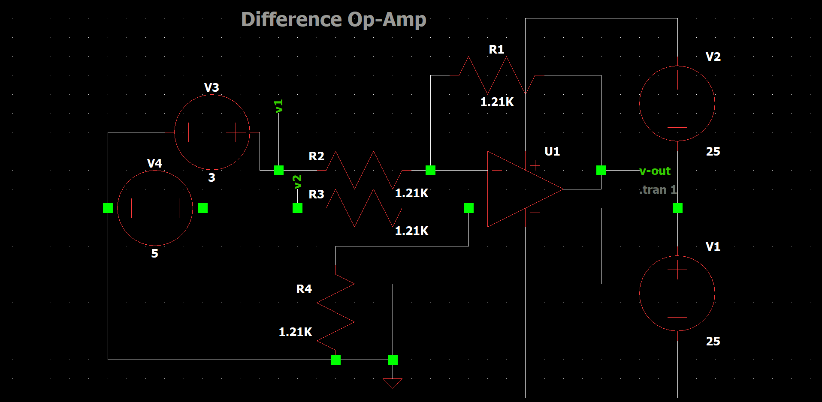
2.Waveform.
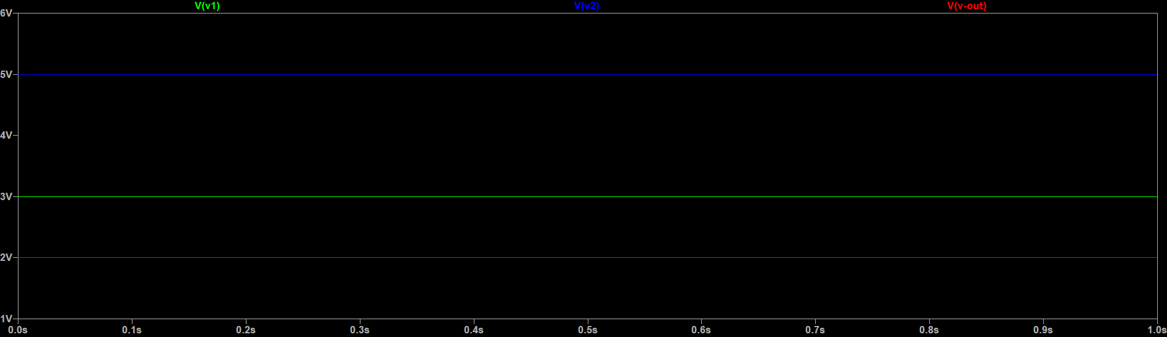
3.Components used.
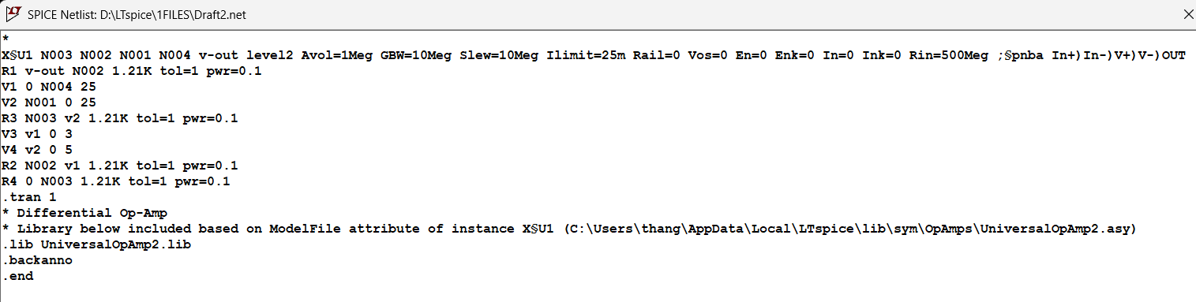
5.Integrator Amplifier.
I/P: PULSE Wave
Von = 1v
T rise & T fall = 1μs
T on = 50ms
T period = 10ms
O/P:
A square wave input was applied, and the resulting triangular output
waveform was obtained and verified.
1.Circuit Diagram.
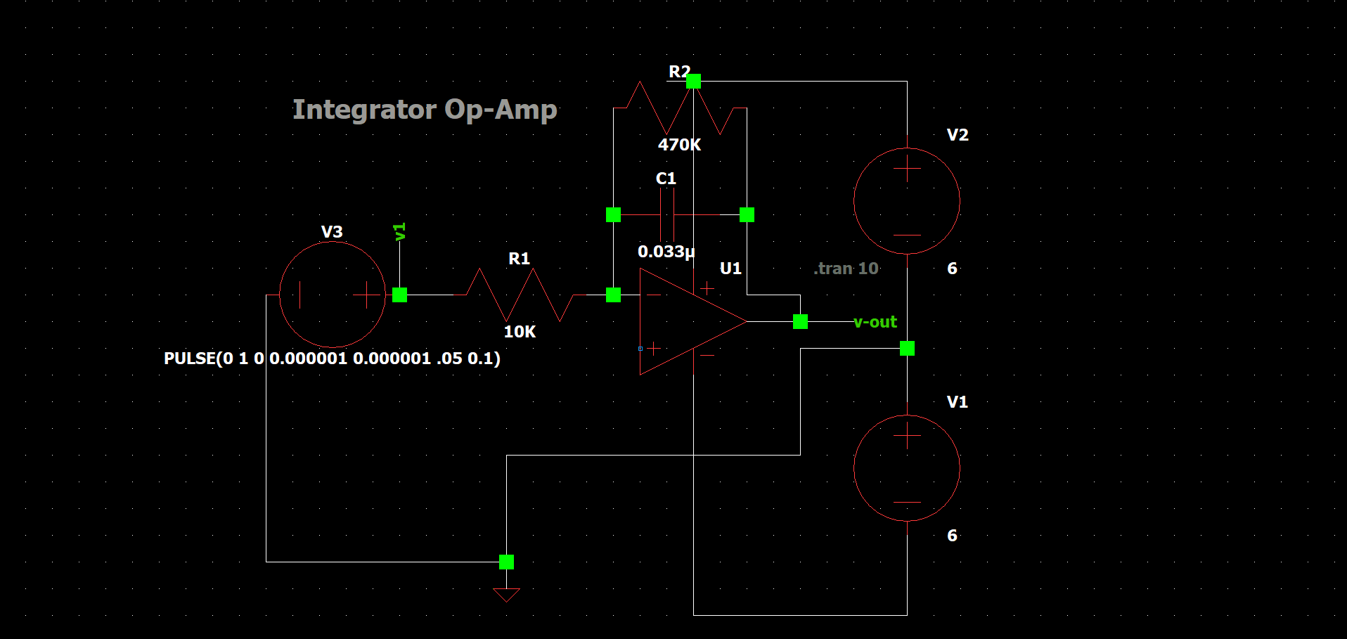
2.Waveform.
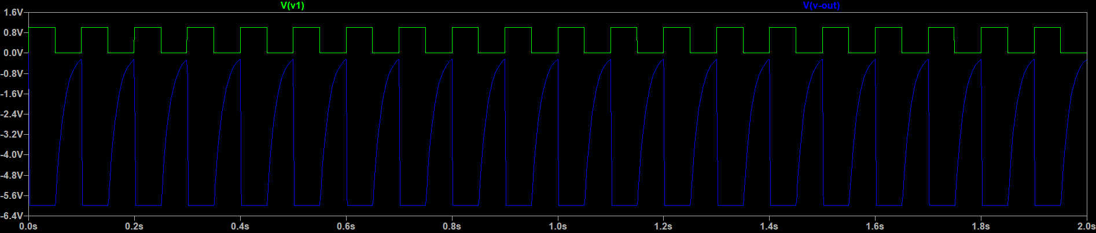
3.Components used.
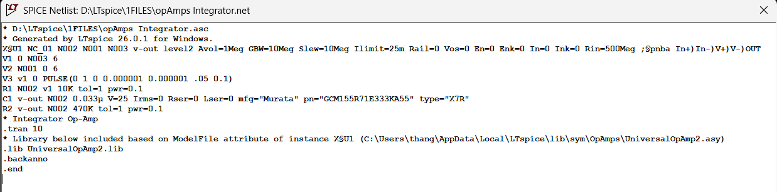
6.Differentiator Amplifier.
I/P: SINE Wave
Amplitude[V]: 1v
Freq[Hz]: 60Hz
O/P:
A sine wave input was applied and the output obtained and verified.
1.Circuit Diagram.
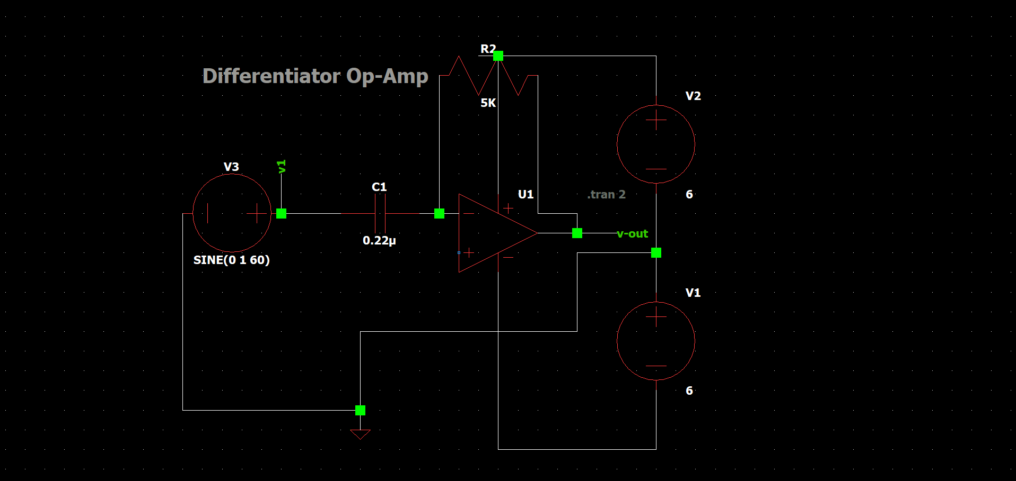
2.Waveform.
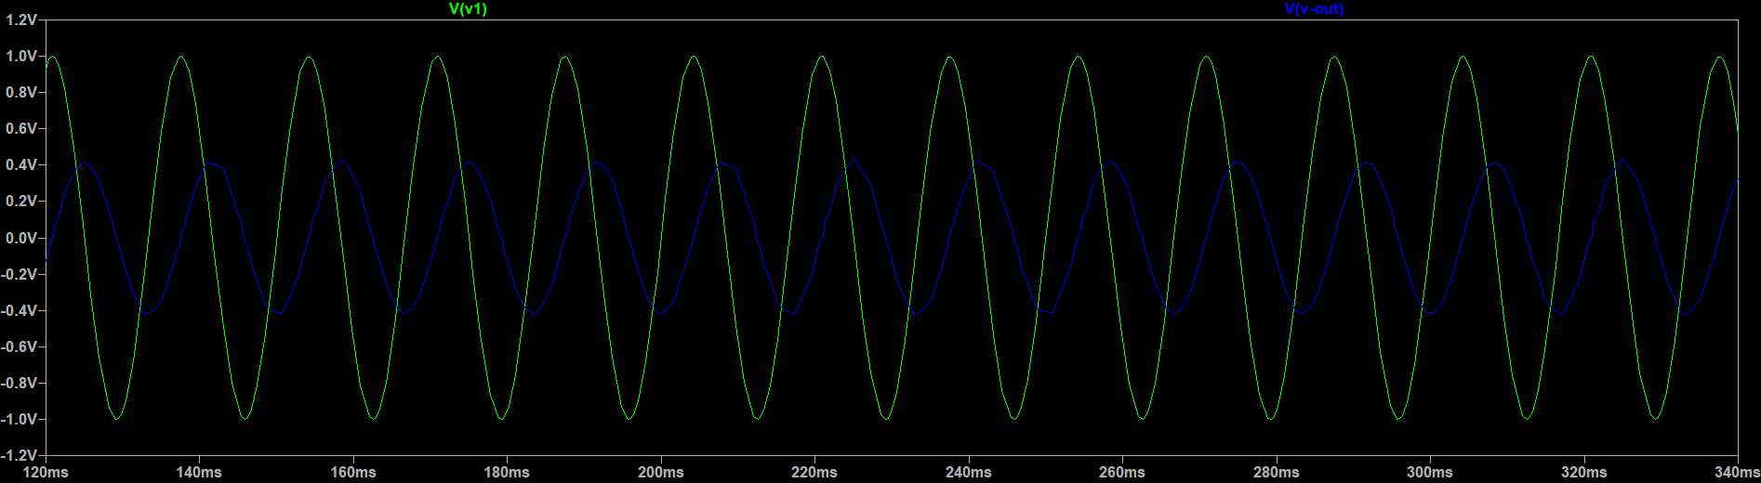
3.Components used.

